**Project 1 – Consumer Behavior Analysis**

While we initially set out to analyze correlations between consumer behavior and weather, we ended up shifting our focus to analyze general patterns in consumer spending. This included comparing spending patterns between women and men, looking at purchase trends among different age groups, and identifying the popularity of items among different demographic groups, among others.

**Research Question**

How do factors like age, gender, location, and season influence consumer spending and preferences regarding items purchased?

**Findings**

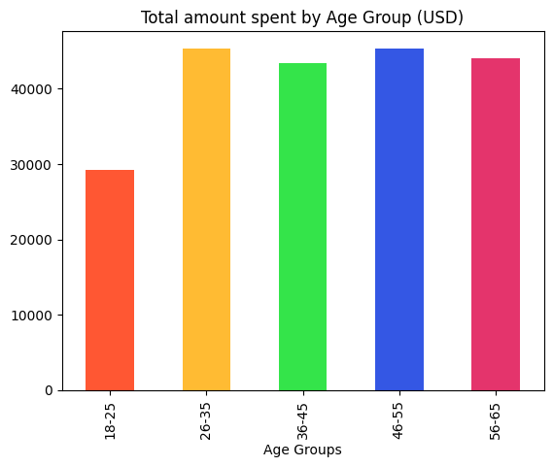

We split our data up by age group to analyze how spending patterns vary among the different groups. We found that those in the 26-35 age group spent the most, while those in the 18-25 age group spent the least. Spending levels were fairly similar across the other age groups.

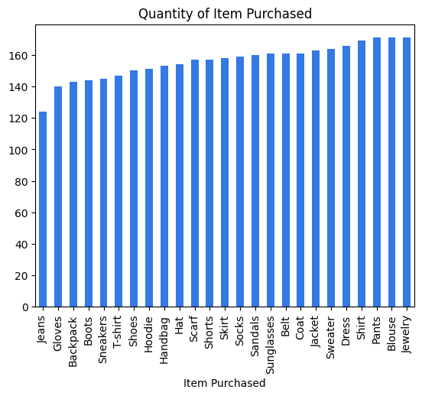

We then examined trends in what kinds of items consumers are purchasing most frequently. Our findings show that jewelry was the most commonly purchased item, followed closely by blouses and pants. The least commonly purchased item was jeans.

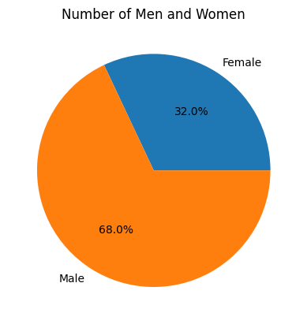

Men made up 68% of this sample, while women made up 32%.

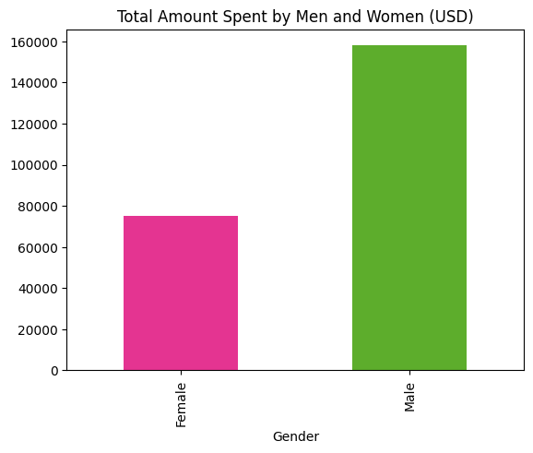

Our data shows that men spent about twice as much as women, which makes sense as there were about twice as many men in the population sampled as there were women.

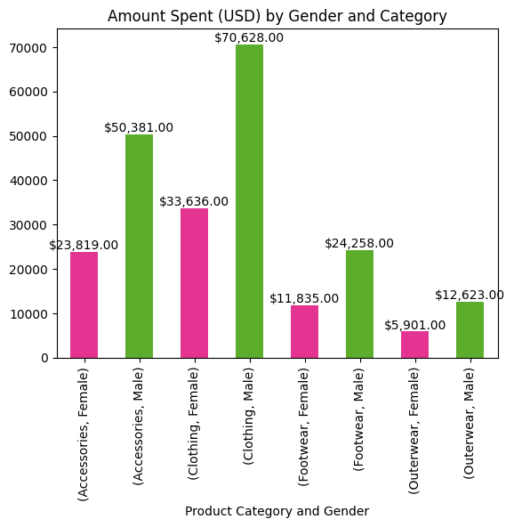

The data shows that men and women purchases followed the same trends- they both spent the most on clothing, about $70,000 and about $33,000 respectively, and the least on outerwear, at approximately $12,000 and about $6,000.

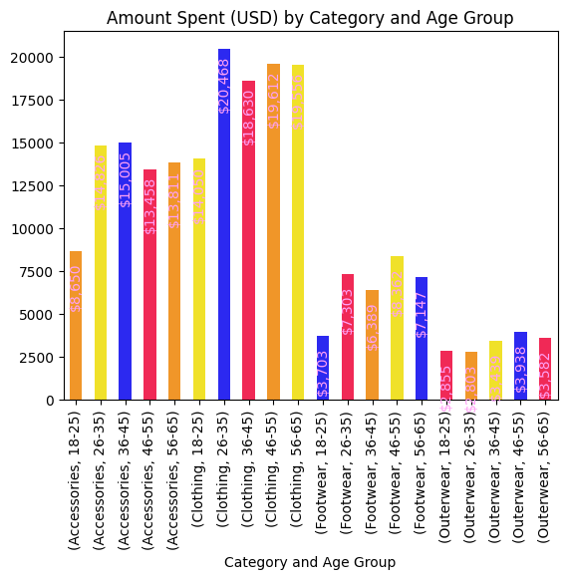

From this chart, we can see that clothing was the most purchased category, which makes sense since our gender data reflected the same. We can also see that members of the 26-35 age group purchased the most within any of the categories, at $20,468 spent on the clothing category. This is in line with our finding that individuals in the 26-35 age group spent the most overall.

The least purchased category was outerwear, with $2,803 spent by the 26-35 age group.

Across all age groups, individuals spent much more on clothing and accessories than they did on footwear and outerwear.

**Correlations Between Expense, Purchase Frequency, and Age/Gender**

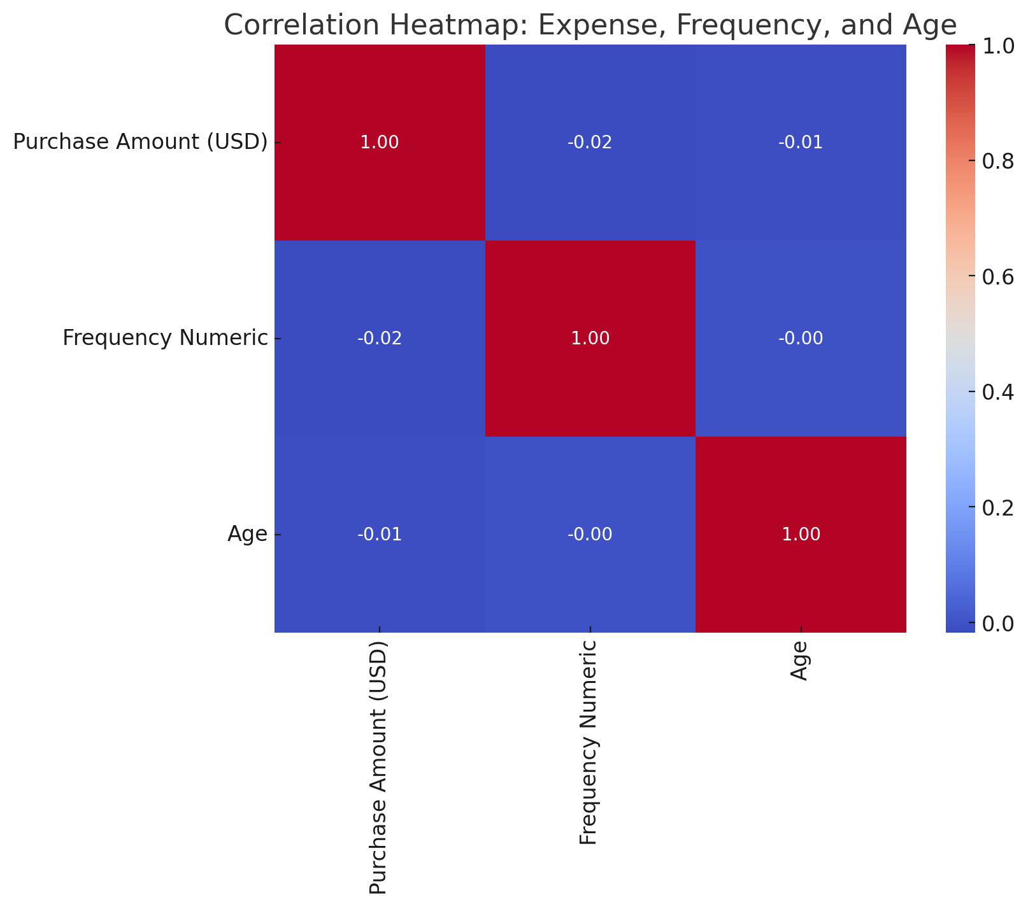

The correlation matrix shows the following relationships:

1. **Purchase Amount (USD) and Frequency of Purchases**: A very weak negative correlation (-0.018), suggesting almost no linear relationship between how much people spend and how frequently they purchase.
2. **Purchase Amount (USD) and Age**: An extremely weak negative correlation (-0.010), indicating that age has almost no effect on how much customers spend.
3. **Frequency of Purchases and Age**: Similarly, a very weak negative correlation (-0.004), showing that age does not significantly affect how often customers make purchases.

**How expense varies across locations**

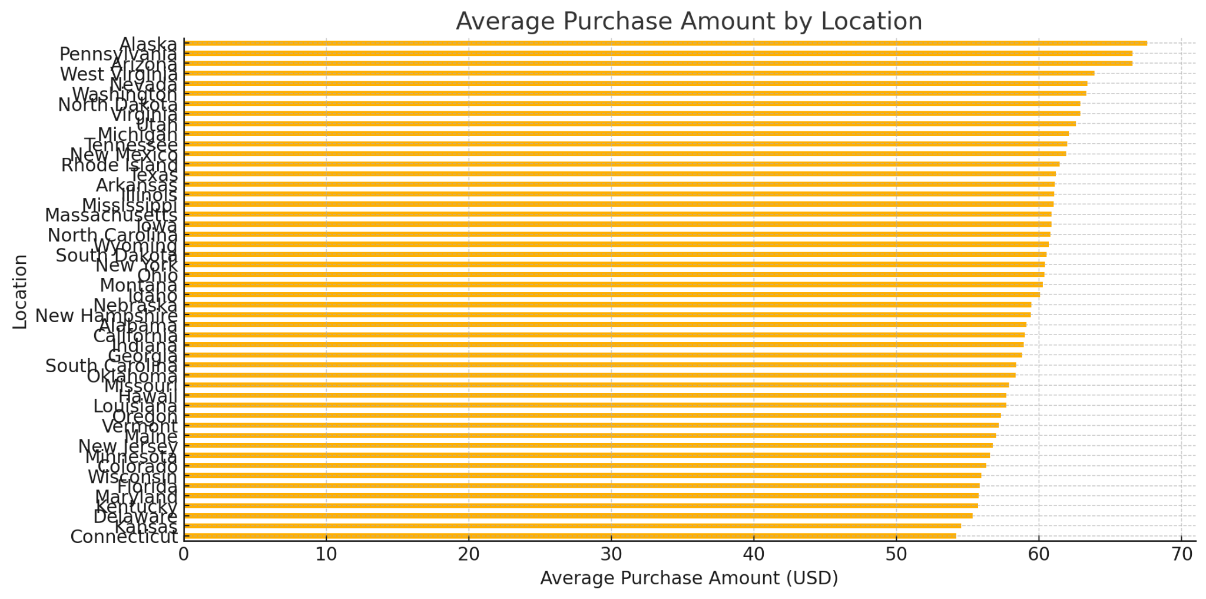

The locations with the highest average purchase amounts are:

1. **Alaska**: $67.60
2. **Pennsylvania**: $66.57
3. **Arizona**: $66.55
4. **West Virginia**: $63.88
5. **Nevada**: $63.38

Location Alaska 67.597222

Pennsylvania 66.567568

Arizona 66.553846

West Virginia 63.876543

Nevada 63.379310

Washington 63.328767

North Dakota 62.891566

Virginia 62.883117

Utah 62.577465

Michigan 62.095890

**Subscribers vs Non-Subscribers**

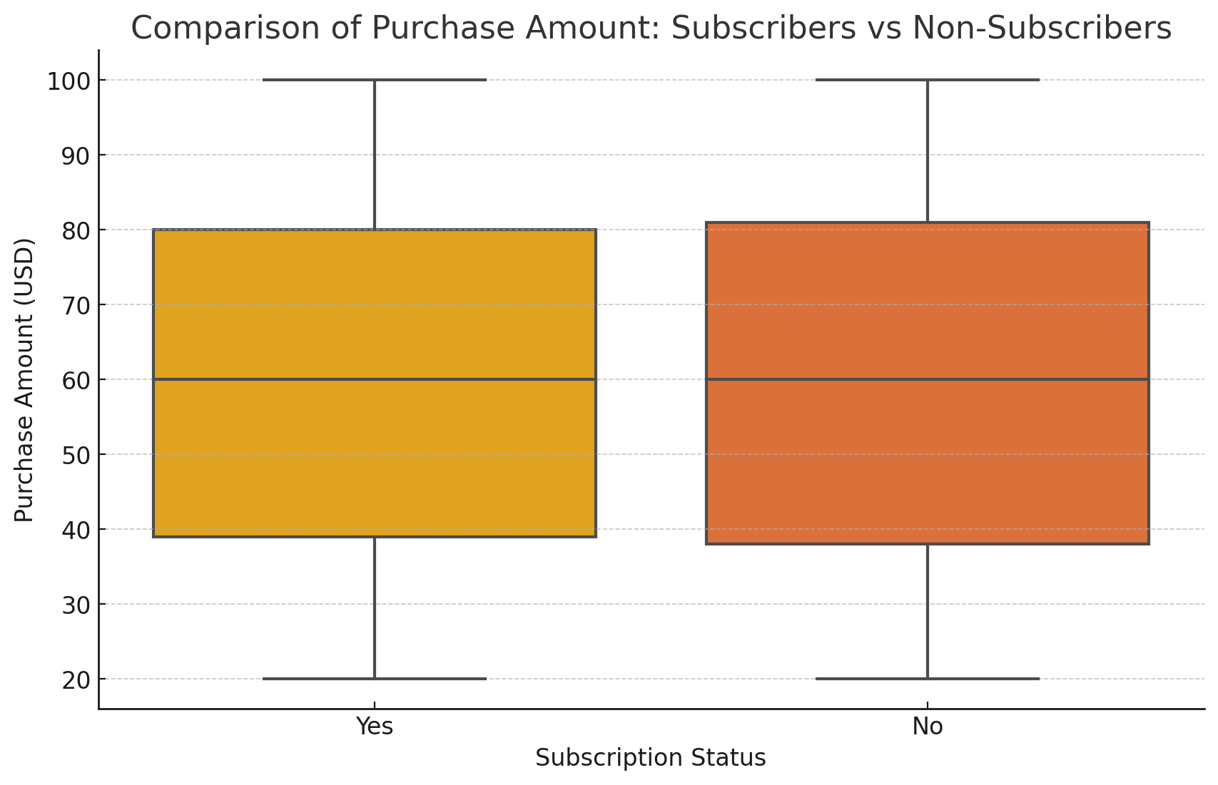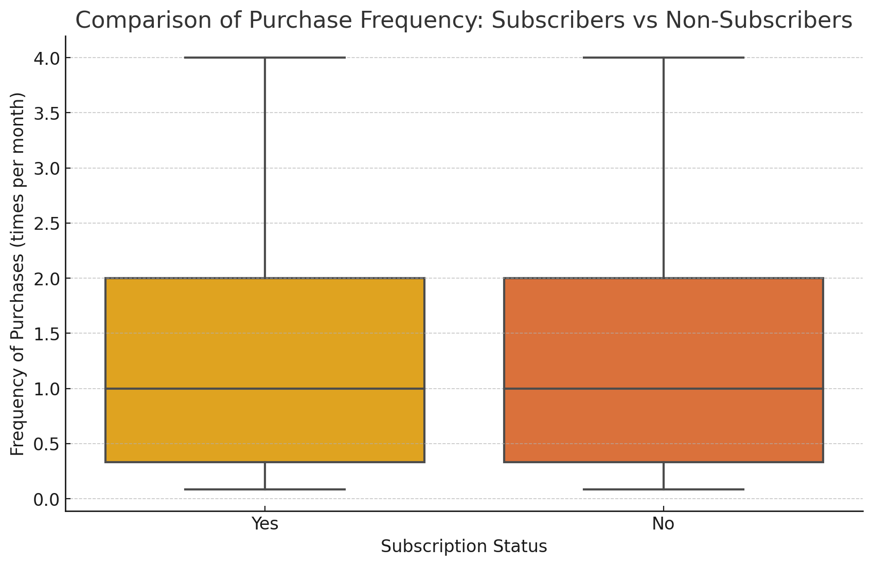

**Purchase Amount Comparison**:  
This box plot shows the distribution of purchase amounts for subscribers and non-subscribers. You can observe whether subscribers generally spend more and if there are any outliers.

**Purchase Frequency Comparison**:  
This box plot illustrates the frequency of purchases for both groups. It helps highlight whether subscribers shop more frequently on average compared to non-subscribers.